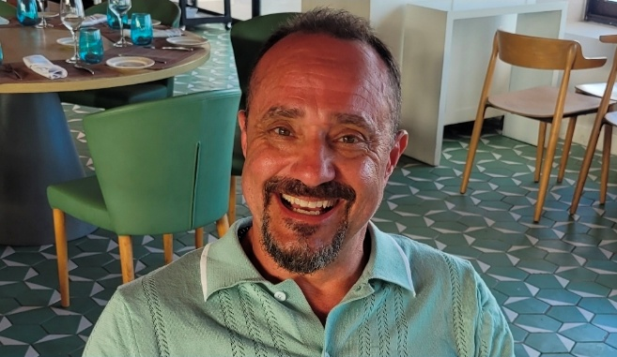
JOHN PAUL SANTOS
701-299 Mill Road, Etobicoke, ON M9C 4V9
416-670-5347 | Rowzwood41@gmail.com

CONSTRUCTION PROFESSIONAL | HANDYMAN | CARPENTER
Highly skilled and dependable construction professional with 35+ years of hands-on experience in residential and commercial construction. Extensive experience in rough and finish carpentry, renovations, painting, repairs, maintenance, and general construction. Proven ability to work independently or as part of a team while maintaining quality, safety, and project timelines. Reliable, detail-oriented, and available to start immediately.

CORE SKILLS
- Rough & Finish Carpentry
- Handyman Services & General Repairs
- Residential Renovations
- Interior & Exterior Painting
- Framing, Drywall & Trim
- Door & Window Installation
- General Construction & Labour
- Hand & Power Tools
- Site Cleanup & Safety
- Maintenance & Repairs
- Independent & Team-Based Work
- Time Management & Reliability

PROFESSIONAL EXPERIENCE

VALERY HOMES — Finish Handyman
2025
- Provided on-site handyman and repair services for residential developments.
- Completed finishing details, punch-list items, and general maintenance tasks.
- Performed carpentry repairs, touch-ups, and finishing work.
- Completed interior and exterior painting.
- Supported construction teams in completing projects to quality standards and deadlines.

PRIMONT HOMES — Finish Handyman
2024–2025
- Performed general repairs and maintenance on residential properties.
- Completed carpentry, finishing, repair, and touch-up work.
- Assisted with construction and handyman services as required.
- Maintained quality workmanship while meeting project deadlines.

LINDVEST — Finish/Service Handyman

2023–2025
- Conducted routine maintenance, repairs, and minor renovations.
- Supported project teams with carpentry, painting, and general construction tasks.
- Completed interior and exterior painting.
- Performed finishing and repair work to maintain residential properties.

KAYOLA PAINTING & RENOVATIONS — Owner / Handyman / Carpenter / Painter
2018–2022
- Operated a residential renovation and painting business.
- Managed projects from planning through completion.
- Performed carpentry, painting, repairs, renovations, and finishing work.
- Coordinated materials and day-to-day project requirements.
- Built strong customer relationships through reliable service and quality workmanship.

LUXURY MAIDS SERVICE — Service Technician / Handyman
2016–2022
- Maintained and renovated kitchens, bathrooms, and residential spaces, including work in senior living facilities.
- Renovated senior living suites from existing layouts to updated finishes.
- Repaired and renovated rental apartments through contracted renovation projects.
- Performed general maintenance, repairs, painting, and finishing work.
- Managed cleaning supply inventory and improved purchasing efficiency.
- Trained new staff on cleaning and safety procedures.

IRONCLAD RENOVATIONS — Handyman
2016–2018
- Renovated senior living suites and rental apartment units.
- Performed framing, trim installation, door and window fitting, drywall repair, and finishing.
- Measured, cut, and assembled construction materials using hand and power tools.
- Completed repairs and renovations according to project specifications.

METRO CARPENTRY — Carpenter, Rough & Finish / Painter
2007–2016
- Performed rough and finish carpentry on residential construction projects.
- Completed interior and exterior painting.
- Worked with contractors and construction crews to meet project timelines and specifications.
- Measured, cut, assembled, and installed construction materials.

AVIVA CONSTRUCTION — Carpenter
2009
- Assisted with framing and general carpentry tasks.
- Supported construction crews with site preparation and material handling.
- Assisted with general construction duties and job-site organization.

CERTIFICATIONS & TRAINING
- LIUNA Local 183 Member
- Working at Heights
- WHMIS
- First Aid & CPR
- Hand & Power Tool Operation

AVAILABILITY
- Available immediately
- Flexible schedule
- Willing to travel for work, including Wasaga Beach and Kleinburg, ON

